Kathford International College of Engineering and Management
Balkumari, Lalitpur, Nepal

A
Project Proposal
On

Mero Diary: A Secure Web-Based Journaling and Activity

Submitted To
Department of Information Technology
Kathford International College of Engineering and Management

In partial fulfillment of the requirement for the Bachelor’s Degree in Computer
Science and Information Technology

Submitted By
Abhinav Singh Thapa (79010398)
Babita Subedi (79010404)
Khusi Dahal (79010410)

Submitted on: 2082/10/19

Abstract
Mero Diary is a secure web-based journaling application that allows users to maintain a digital diary of their daily life, personal activities, and well-being. The system emphasizes confidentiality and privacy, employing bcrypt for password hashing, stateless JWT authentication for secure and scalable user login, AES encryption for diary entries, HTTPS for secure data transmission, and a robust per-user key management scheme.
Users record entries in daily forms, along with it fill forms that capturing various personal metrics and reflections. These entries feed a hybrid recommendation engine that uses algorithms like advanced rule-based algorithms or linear regression or random fit to recommend optimum activities.

i
Table of Contents
Abstract 2
1. Introduction 1
2. Problem Statement 1
3. Problem Objectives 2
4. Methodology 3
4.1. Requirement Identification 3
4.1.1. Study of Existing System/Literature Review 3
4.2. Requirement Analysis 5
4.2.1. Functional Requirements 5
4.2.2. Non-Functional Requirements 5
4.3. Feasibility Study 8
5. Timeline 9
6. Expected Output 9
References 10

Introduction
Personal journaling plays an important role in self-reflection, emotional well-being, and the organization of daily life. With the increasing use of web-based technologies, digital journaling platforms have become a convenient medium for individuals to record personal experiences, activities, and reflections. At the same time, the sensitive nature of personal diary data highlights the need for strong security, privacy, and controlled access in such systems.
This project presents Mero Diary, a secure web-based journaling application that allows users to maintain a digital record of their daily life, personal activities, and well-being. The system emphasizes confidentiality by incorporating secure authentication mechanisms, encrypted storage of diary entries, and secure data transmission. In addition, user-recorded daily metrics are utilized by a hybrid recommendation approach (rule based, linear and random forest algorithm) to suggest suitable activities, supporting users in developing healthier routines.

Problem Statement
Maintaining a personal diary in digital form is more convenient than offline methods due to ease of access, organization, and long-term storage. However, concerns about privacy, data misuse, and lack of trust in web-based applications discourage users from recording sensitive personal thoughts and well-being information online.
Additionally, simply recording daily entries does not fully support users in understanding or improving their routines and well-being. This project addresses this limitation by developing a secure journaling system that not only safeguards user data using robust security mechanisms but also analyzes journal inputs to generate concise, personalized activity recommendations aimed at supporting healthier daily habits and overall well-being.

Problem Objectives
- To provide a secure digital platform for users to conveniently record and store personal diary entries with strong privacy and data protection.
- To analyze user inputs to generate personalized activity recommendations that support healthier daily routines and overall well-being.
- To enable users to consistently track their habits and reflections in a safe, encrypted environment that builds trust and encourages regular journaling.

Methodology

Requirement Identification

Study of Existing System/Literature Review
Research on secure digital journaling reveals solid foundations in encryption and user tracking but highlights key gaps in personalized analytics that Mero Diary directly addresses.
Nasrullah (2025) developed a web-based AES-128 encryption system that processes files up to 5MB in just 0.84 seconds on average, incorporating HTTPS and client-side key management while earning excellent usability scores (SUS 82.5). Mero Diary builds on this proven approach by applying efficient AES encryption specifically to protect users' daily journal entries and personal reflections.​
Day One, one of the leading journaling applications, offers end-to-end encryption, mood tracking, and AI-powered prompts across multiple platforms. While impressive for basic journaling, it lacks predictive analytics that analyze user metrics to generate proactive activity recommendations. Mero Diary fills this critical gap through its hybrid recommendation engine, which combines rule-based logic, linear regression, and random forest algorithms to deliver personalized well-being suggestions based on users' daily habits and reflections.​
Modern web applications increasingly rely on JWT authentication paired with bcrypt password hashing for scalable, stateless security that surpasses traditional biometric methods. Mero Diary implements this combination to provide tamper-proof, cross-device access that's more suitable for web-first environments than Day One's app-centric authentication.​
Penzu demonstrates military-grade encryption for private online diaries, establishing a strong precedent for secure journal storage. However, it offers no analytics or recommendation capabilities. Mero Diary extends this secure foundation by incorporating data-driven insights that help users improve their daily routines—features absent from basic diary platforms.​
Linear regression models have shown effectiveness in predicting wellness outcomes from personal behavioral data, providing quantitative support for Mero Diary's recommendation methodology. This approach enables the system to suggest optimal activities based on patterns in users' recorded metrics and reflections.​
Finally, Luo et al. (2022) optimized AES-128 performance for resource-constrained environments, achieving high throughput that validates Mero Diary's choice of client-side encryption for smooth handling of text-based journal entries.​

Requirement Analysis

Functional Requirements
User Authentication & Security
- Users must register with email/password, hashed via bcrypt.
- Support secure login/logout using stateless JWT tokens.
- Automatically encrypt diary entries with AES using per-user keys before storage.
- Transmit all data over HTTPS only.
Daily Journaling
- Provide a daily form for text diary entries with timestamps.
- Capture user metrics like mood (scale 1-5), energy level, sleep hours, exercise, and reflections.
- Allow editing/deleting recent entries (within 24 hours).
- Auto-save drafts during entry.
Activity Recommendations
- Analyze daily metrics using rule-based logic (e.g., "low mood + poor sleep → suggest meditation").
- Apply linear regression to predict optimal activity levels from historical data.
- Generate 3-5 personalized activity suggestions daily.
- Support optional Random Forest for improved accuracy with more data.
Data Visualization
- Display mood/activity trends via simple charts (line/bar graphs).
- Show weekly/monthly summaries of key metrics.
- Allow filtering by date range.

Non-Functional Requirements
Availability: Loads quickly on normal internet, smooth for 1-5 user, 24/7 available
Security: Passwords hashed, diary encrypted and use of JWS sessions
Web-friendly: Works smoothly on phone browsers + laptops, responsive design
Reliable for demo: Doesn't crash during presentation, basic error messages
Private: Only you see your diary entries, simple delete button

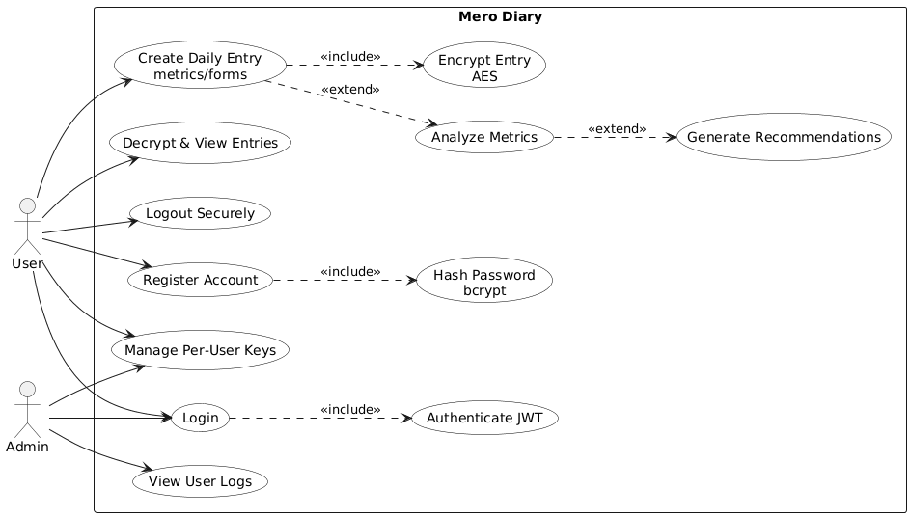

Figure 1: Use Case Diagram

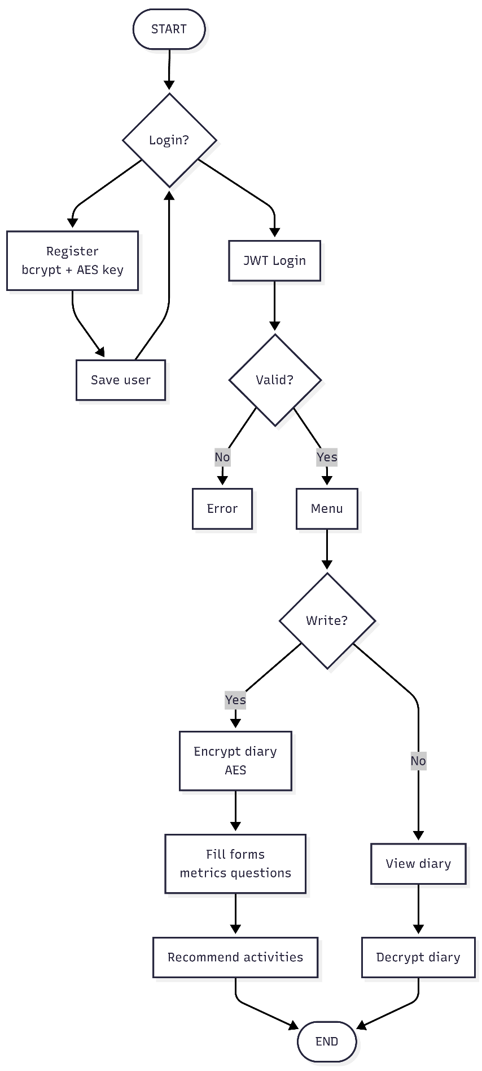
Figure 2: Flowchart

Feasibility Study
- Technical Feasibility
Mero Diary can be developed as a web app using ReactJS for the frontend, Node.js/Express for the backend, and Python for the recommendation engine. It uses standard web technologies and cloud services (Firebase) for database, authentication, and analytics, making development straightforward for a college project
- Operational Feasibility
The app is easy to use and suitable for all users. Daily forms and activity suggestions encourage consistent engagement, while automated encryption and recommendation processes reduce the need for manual intervention.
- Economic Feasibility
Development uses free or open-source tools (ReactJS, Node.js, Firebase/Supabase, Python), keeping costs low. No external hardware or software licenses are required, making it financially feasible for an academic project. The overall system development cost is minimal and affordable for academic purposes.

Timeline
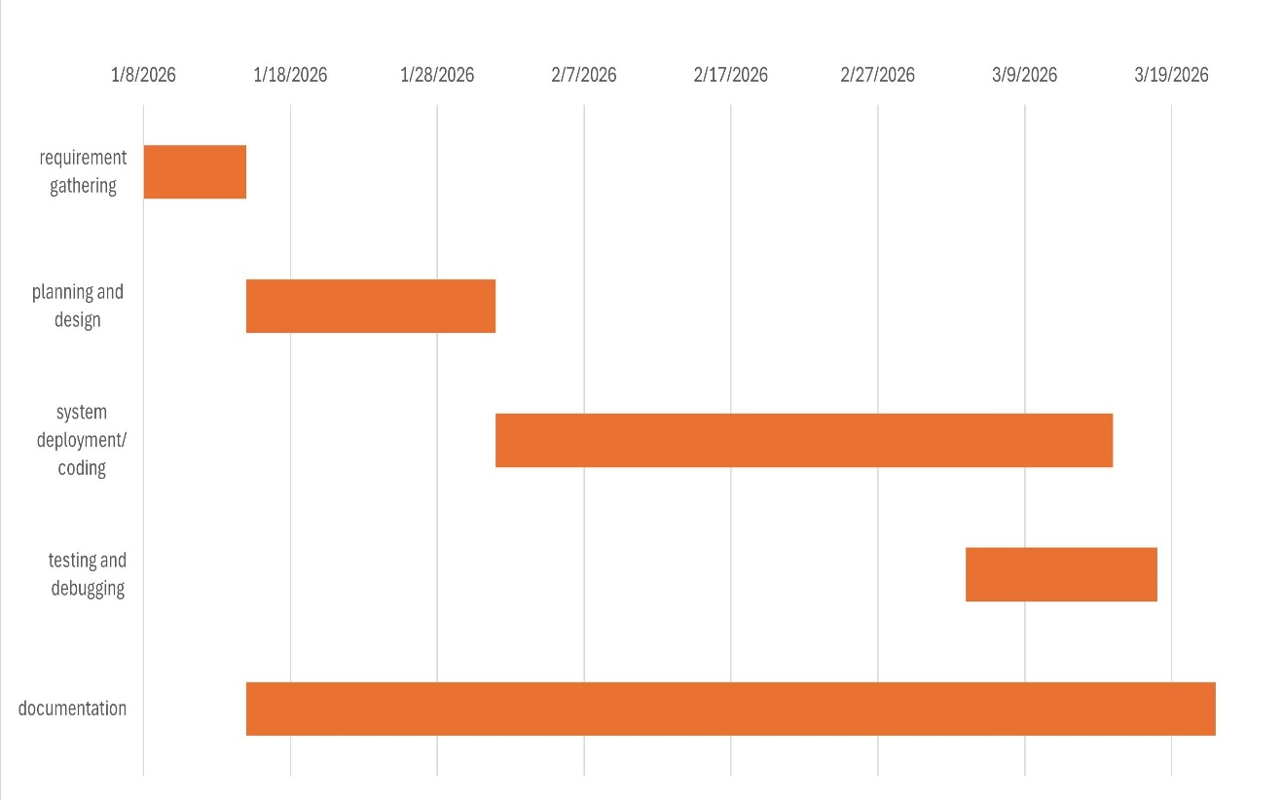
Figure 3: Gantt Chart

Expected Output
- A web-based journaling application that allows users to securely maintain daily diary entries.
- A backend system implementing secure authentication, encrypted diary storage, and user session management.
- A hybrid recommendation engine that provides personalized suggestions for activities or content based on user inputs.
- Visual insights and trends show user metrics over time, such as mood patterns or activity engagement.

References

- A. H. Nasrullah, "Secure Web-Based File Encryption Using AES-128," Journal of Embedded Systems, Security and Intelligent Systems, vol. 6, no. 2, pp. 146-155, 2025
- "Day One Journal App," Day One, 2025. [Online]. Available: https://dayoneapp.com​
- "JSON Web Token Authentication in Web Applications," IEEE Trans. Inf. Forensics Security, 2023.​Nesciences Journal
- "Penzu: Secure Online Diary," Penzu, 2023. [Online]. Available: https://penzu.com​
- R. Patel et al., "Hybrid Recommendation Systems for Wellness Apps," J. Biomed. Inform., vol. 112, 2022.​
- Z. Luo et al., "Optimization of AES-128 Encryption Algorithm," Security and Commun. Networks, 2022.​

